Eexplore the life and work of Henri Matisse
To find out more about his life and work, follow the links below:
https://www.tate.org.uk/kids/explore/who-is/who-henri-matisse https://www.ducksters.com/biography/artists/henri_matisse.php
As he got older, he started using cut outs and collage to create his work.
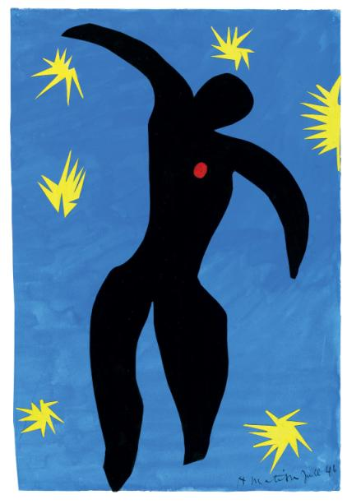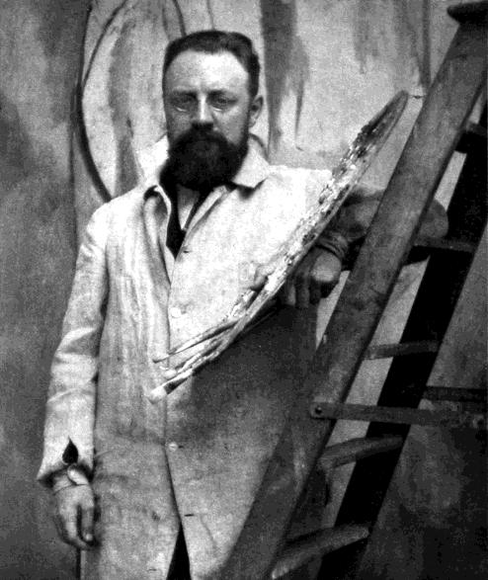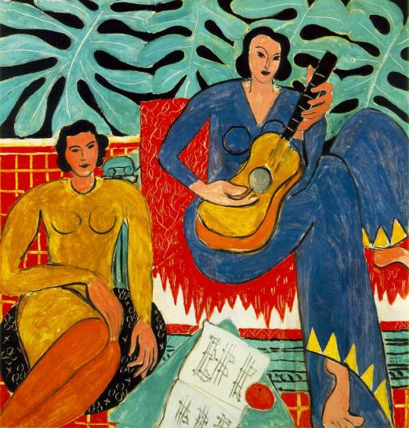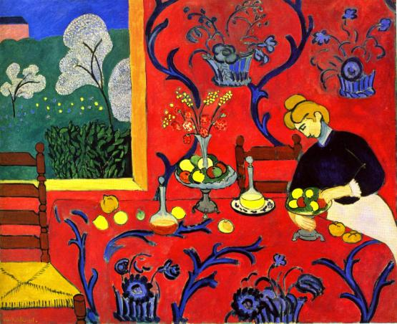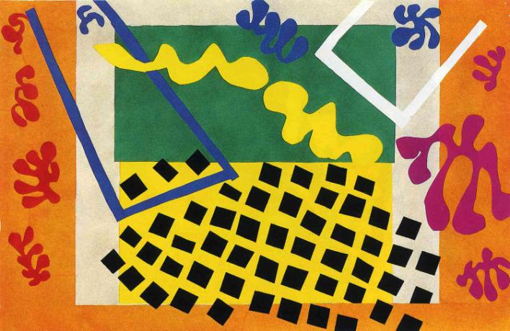
Your task:
Create your own collage inspired by the work of Henri Matisse. The website below will tell you everything you need to know:
https://www.tate.org.uk/kids/make/cut-paste/collage-matisse-snail
Don’t worry if you don’t have lots of colourful paper to hand, use recycled material to create an eco-friendly design.
Have a look at these examples from other primary schools –
